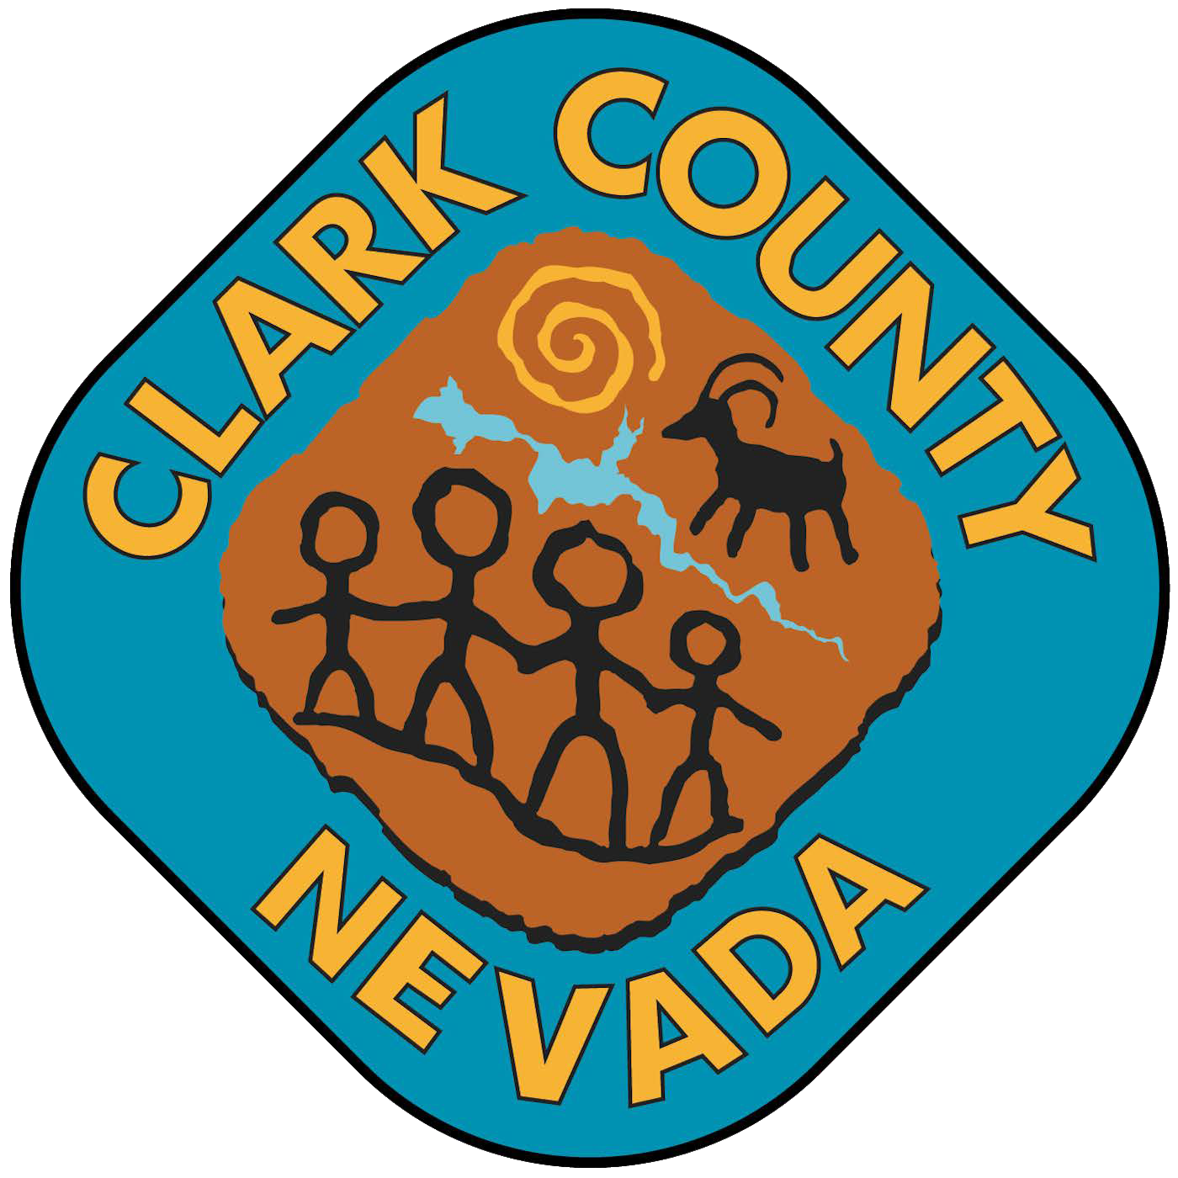

Office of the Clark County Treasurer
J. Ken Diaz, County Treasurer
Jonathan Newton, Assistant Treasurer | May-Anne Alibin, Deputy Director
O: 702-455-4323 | F: 702-455-5969 | TRCustomerService@ClarkCountyNV.gov

TAX CERTIFICATION REQUEST FORM
Request Information:
Date of Request
Total Cost
Assessor’s Parcel Number(s) (APN):
Property/Map Information: (At least one of the following three fields must be completed)
New Parcel Map Number (MSM #)
New Final Map Number (NFM #)
Land Division Number (LD #)
Subdivision Name (Optional)
Requestor/Company Information:
Company Name
Company Address
Contact Person
Phone Number

Fees and Processing Time:
Certification Fee | $1.00 per page
Processing Time | Please allow two (2) business days for preparation
Please ensure all required information is provided to avoid delays in processing your request.

TREASURER’S OFFICE USE ONLY
Researched Completed By: |  |  | Research Completion Date:
Reviewed By: |  |  | Notification to Requester Date:

500 S. Grand Central Pkwy. | Box 551220 | Las Vegas, NV 89155-1220 | www.ClarkCountyNV.gov/treasurer
Revised 10/2026

